Theme/Term | Crime & punishment Autumn 1 |  | Power vs. principles Autumn 2  Cycle A
Writing Root/  Spelling Seed Text | 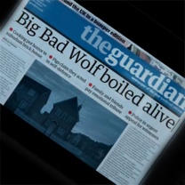  The Three Little Pigs Project  The Guardian | 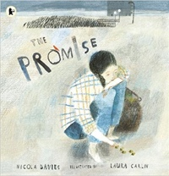  The Promise  Nicola Davies | 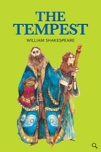  The Tempest  William Shakespeare |  | 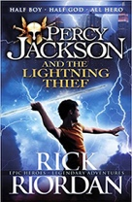  Percy Jackson  Rick Riordan
Length | 12 sessions, 2+ weeks | 15 sessions, 3 weeks | 14+ sessions, 3 + weeks |  | 20 sessions, 4 weeks
Outcomes | Discussion texts  News reports, persuasive speeches, interview scripts, diaries, debates, narratives | Narrative poem sequels  Promises, extended thought bubbles, diary entries, letters in role, figurative captions, summary poems | Playscripts  Setting descriptions, character descriptions, diaries, dialogue |  | Mythical narratives  Odes, soliloquies, setting descriptions, additional chapters, reports
Literary Leaf Text | 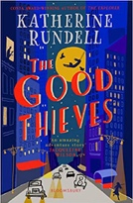  The Good Thieves  Katherine Rundell
Theme/Term | Affirmation & equality Spring 1 |  | Legends, folklore & fairytales Spring 2
Writing Root/  Spelling Seed Text | 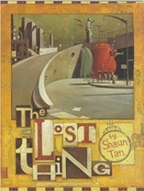  The Lost Thing  Shaun Tan | 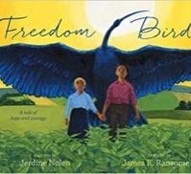  Freedom Bird  Jerdine Nolen | 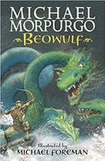  Beowulf  Michael Morpurgo |  | 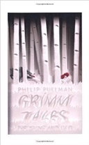  Grimm Tales for Young and Old  Phillip Pullman
Length | 16 sessions, 3+ weeks | 15 sessions, 3 weeks | 15 sessions, 3 weeks |  | 15 sessions, 3 weeks
Outcomes | Own version narratives  Diaries, formal letters, adverts, character and setting descriptions, reports | Biographies Non-narrative poems, explanations, dialogue, postcards, letters of advice, descriptions, recounts, narrative poems | Own version legends Letters of advice, diaries, dialogue, descriptions, action scenes, obituaries |  | Own version traditional tales  Retellings, character studies, monologues, character comparisons
Literary Leaf Text | 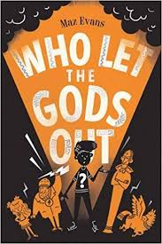  Who Let the Gods Out  Maz Evans  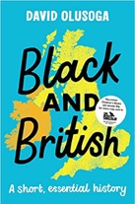
Theme/Term | Lessons from history Summer 1 |  | Solving mysteries Summer 2
Writing Root/  Spelling Seed Text | 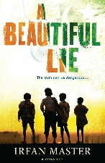  A Beautiful Lie  Irfan Master | 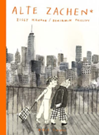  Alte Zachen  Ziggy Hanaor | 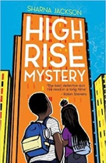  High Rise Mystery  Sharna Jackson |  | 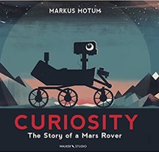  Curiosity  Markus Motum
Length | 16 sessions, 3 weeks | 15 sessions, 3 weeks | 15 sessions, 3 weeks |  | 15 sessions, 3 weeks
Outcomes | New chapters  Journalistic writing, recounts, discussion texts | Analytical essay  Character descriptions, flashbacks, diary entries in role, short autobiographies | Extended stories Character & setting descriptions, police & newspaper report, dialogue, persuasive letters |  | Expanded explanations  NASA Proposals, information labels, short explanations, NASA logs, news reports
Literary Leaf Text | 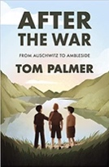  After the War  Tom Palmer
Theme/Term | Journeys & migration Autumn 1 |  |  | Conservation & preservation Autumn 2  Cycle B
Writing Root/  Spelling Seed Text | 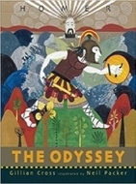  The Odyssey  Gillian Cross | 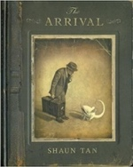  The Arrival  Shaun Tan | 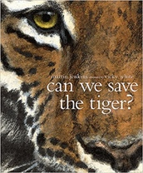  Can We Save the Tiger?  Martin Jenkins |  | 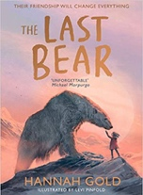  The Last Bear  Hannah Gold
Length | 20 sessions, 4 weeks | 17 sessions, 3+ weeks | 15 sessions, 3 weeks |  | 15 sessions, 3 weeks
Outcomes | Epic stories  Speeches (proclamation, persuasive, soliloquy), dialogue, missing scenes | Extended narratives  Letters, lists of rules, character descriptions, diaries, guides | Discussion texts  Letters, explanations, persuasive posters, & speeches, simple poems |  | Newspaper article  Character profile, dialogue, monologue, logbook entry, scientific report
Literary Leaf Text | Cosmic  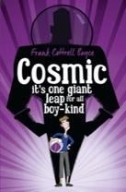  Frank Cottrell Boyce
Theme/Term | Inspiration & activism Spring 1 |  | Dystopian worlds Spring 2
Writing Root/  Spelling Seed Text | Hidden Figures  Margot Lee Shetterly  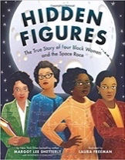 | 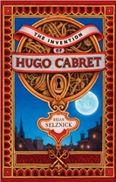  OR The Invention of Hugo Cabret  Brian Selznick |   Robot Girl  Malorie Blackman |  | 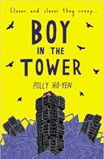  Boy in the Tower  Polly Ho-Yen
Length | 17 sessions, 3+ weeks | 17 sessions, 3+ weeks | 15 sessions, 3 weeks |  | 15 sessions, 3 weeks
Outcomes | Non-chronological report  Reports, formal and informal letters, diaries, character descriptions, journalistic writing | Biographies  Diaries, journalistic writing, flashback narratives, speeches, discussions, letters, film critiques | Science-fiction narratives  Discussions, debates, dialogue, character comparisons, reviews |  | Own version narratives (past and present tense)  Journalistic writing, formal letters, non-chronological reports
Literary Leaf Text | 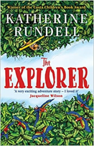  The Explorer  Katherine Rundell
Theme/Term | Fate & fortune Summer 1 |  | A Sense of Place Summer 2
Writing Root/  Spelling Seed Text | 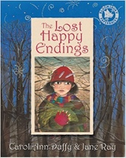  The Lost Happy Endings  Carol Ann Duffy | 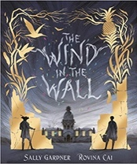  OR The Wind in the Wall  Sally Gardner | 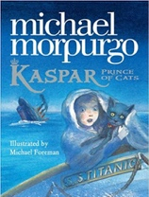  Kaspar, Prince of Cats  Michael Morpurgo |  | 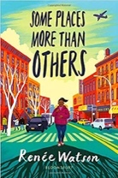  Some Places More Than Others  Renee Watson
Length | 15 sessions, 3 weeks | 15 sessions, 3 weeks | 15 sessions, 3 weeks |  | 15 sessions, 3 weeks
Outcomes | Alternative perspective prequels  Letter, poetry, passage of direct speech, diary entry, story ending | Extended Gothic narrative Horror film poster, figurative writing, descriptions, old English letter, dialogue | Newspaper articles  Character descriptions, reports, letters, advertising leaflets, balanced reports |  | Poems with similar structure  Summaries, analysis and performances
Literary Leaf Text | 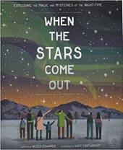  When the Stars Come Out  Nicola Edwards

Y5/6 available alternative texts…

Literary Leaf Text | 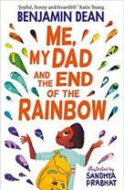  Me, My Dad and the End of the Rainbow  Benjamin Dean | 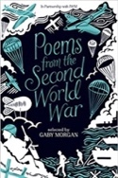  Poems from the Second World War  Gaby Morgan | 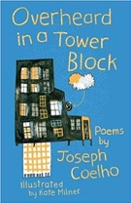  Overheard in a Tower Block  Joseph Coelho | 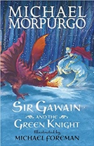  Sir Gawain and the Green Knight  Michael Morpurgo | 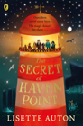  The Secret of Haven Point  Lisette Auton

