Theme/Term | Magic & mystery Autumn 1 |  | Dreams & desires Autumn 2  Cycle A
Writing Root/  Spelling Seed Text | 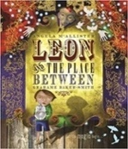  Leon and the Place Between  Angela McAllister | 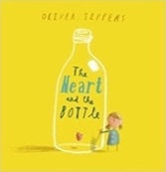  The Heart and the Bottle  Oliver Jeffers | 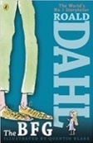  The BFG  Roald Dahl | 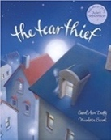  The Tear Thief  Carol Ann Duffy
Length | 15 sessions, 3 weeks | 15 sessions, 3 weeks | 15 sessions, 3 weeks | 15 sessions, 3 weeks
Outcomes | Own version fantasy narratives  Persuasive posters, setting descriptions, thought bubbles/diaries, dialogue | Own version ‘dilemma’ narratives  Dialogue, postcard, character description, diary entry, poetry, letter of advice | Own version fantasy narratives  Recount (diary entry), character descriptions, wanted posters, new chapters, instructions | Newspaper article  Shared poems, diary entries, persuasive posters, letters of explanation, discussions
Literary Leaf Text | 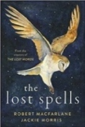  The Lost Spells  Robert MacFarlane |  | 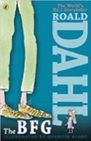  The BFG  Roald Dahl
Theme/Term | Hope & healing Spring 1 |  | Overcoming adversity Spring 2
Writing Root/  Spelling Seed Text | 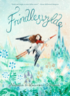  Frindleswylde  Natalia O’Hara & Lauren O’Hara | 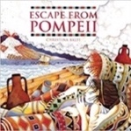  Escape from Pompeii  Christina Balit | 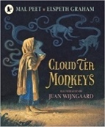  Cloud Tea Monkeys  Mal Peet | 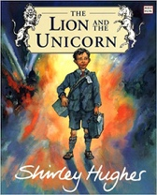  The Lion and the Unicorn  Shirley Hughes
Length | 16 sessions, 3+ weeks | 16 sessions, 3+ weeks | 15 sessions, 3 weeks | 18 sessions, 3+ weeks
Outcomes | Narrative sequels  Letters, voting slips, dialogue, poetry, birds-eye view descriptions, speeches | Newspaper reports  Setting descriptions, diaries, letters, thought bubbles | Non-chronological reports  Descriptions, ‘how to’ guides (instructions), letters, discussions | Own historical narratives  Letters, diaries, character and setting descriptions, non-chronological reports
Literary Leaf Text | 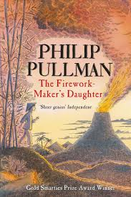  The Firework Maker's Daughter  Philip Pullman |  | 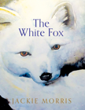  The White Fox  Jackie Morris
Theme/Term | From mystery to discovery Summer 1 |  | Pride & downfall Summer 2
Writing Root/  Spelling Seed Text | 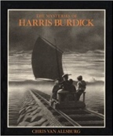  The Mysteries of Harris Burdick  Chris Van Allsberg | 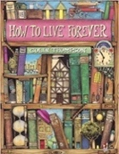  How to Live Forever  Colin Thompson | 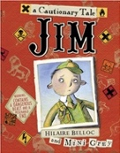  Jim, A Cautionary Tale  Hilaire Belloc | 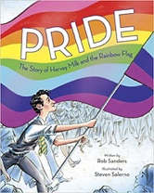  Pride: The Story of Harvey Milk and the Rainbow Flag  Rob Sanders
Length | 15 sessions, 3 weeks | 15 sessions, 3 weeks | 15 sessions, 3 weeks | 10 sessions, 2 weeks
Outcomes | Extended fantasy narrative  Setting description, short first-person narrative, dialogue, speech, action scene | Prequels Lost posters, dialogue, setting and character descriptions, ledger entries, instructions, letters of warning | Narrative poems  Warning posters, warning announcements, alternative endings, performance poetry, letters of apology | Biographies of Harvey Milk  Thought bubbles, speech, simple leaflets
Literary Leaf Text | 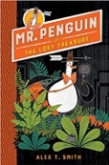  Mr Penguin and the Lost Treasure  Alex T. Smith |  | 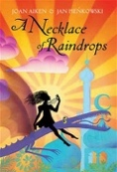  A Necklace of Raindrops  Joan Aiken

Theme/Term | Imagination & freedom Autumn 1 |  | Fantasy worlds Autumn 2  Cycle B
Writing Root/  Spelling Seed Text | 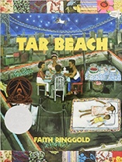  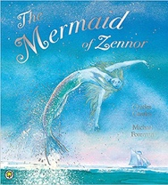  Tar Beach  Faith Ringgold | 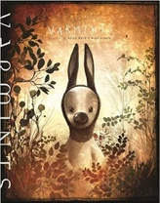  Varmints  Helen Ward | 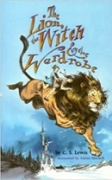  The Lion the Witch and the Wardrobe  C. S. Lewis | 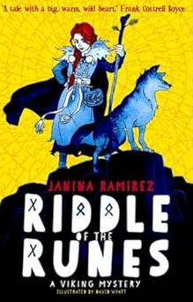  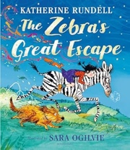  The Zebra’s Great Escape  Catherine Rundell
Length | 15 sessions, 3 weeks | 16 sessions, 3+ weeks | 20 sessions, 4 weeks | 15 sessions, 3 weeks
Outcomes | Narrative retelling as a play script  Poetry, setting descriptions, formal letters, dialogue (as a script) | Explanations of a life cycle  Diary entries, instructions, letters, descriptions, speeches | Own version narratives (set in other worlds)  Poems, eyewitness reports, an imaginary conversations, writing in role | Own version 'great escape' narrative Wanted poster, letter, action scene, poetry, dialogue
Literary Leaf Text | 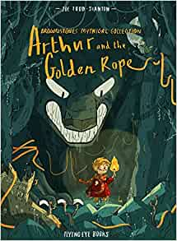  Arthur and the Golden Rope  Joe Todd Stanton |  | 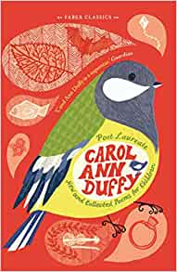  New and Collected Poems for Children  Carol Ann Duffy
Theme/Term | Finding your future Spring 1 |  | Taking Courage Spring 2
Writing Root/  Spelling Seed Text | 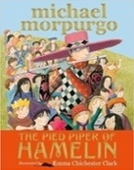  The Pied Piper of Hamelin  Michael Morpurgo | 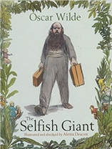  The Selfish Giant  Oscar Wilde | 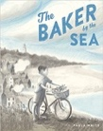  Baker by the Sea  Paula White | 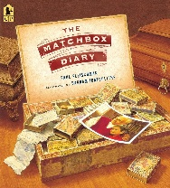  The Matchbox Diary  Paul Fleischman
Length | 15 sessions, 3 weeks | 15 sessions, 3 weeks | 15 sessions, 3 weeks | 15 sessions, 3 weeks
Outcomes | Own version myths/legends  Writing in role, information reports, adverts, formal letters | Own version narratives about kindness  Letters, first person recounts, diaries, letters, posters, reports | Tourist brochures  Job applications, advertisements, setting descriptions, letters in role | Historical fiction narrative (alternative ending)  Character descriptions, crime scene setting descriptions, dialogue, instructions, letter
Literary Leaf Text | 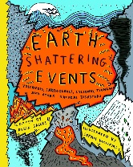  Earth Shattering Events  Robin Jacobs |  | 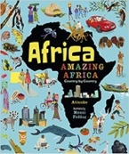  Africa, Amazing Africa  Atinuke
Theme/Term | Unearthing civilisations Summer 1 |  | Invention & transformation Summer 2
Writing Root/  Spelling Seed Text | 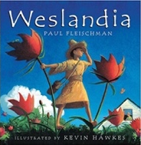  Weslandia  Paul Fleischman | 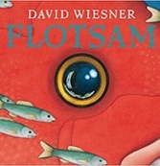  Flotsam  David Wiesner | 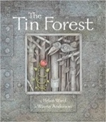  The Tin Forest  Helen Ward | 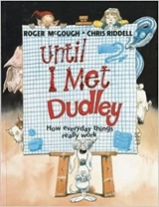  Until I Met Dudley  Roger McGough and Chris Riddell
Length | 15 sessions, 3 weeks | 15 sessions, 3 weeks | 10 sessions, 2 weeks | 10 sessions, 2 weeks
Outcomes | Imagined land narratives  Character description, informative posters, persuasive leaflets, logbook | Sequels (mystery)  Postcard, setting descriptions, non- chronological reports, message in a bottle letters | Persuasive information leaflets  Persuasive posters, information leaflets, postcards, diaries, wishes, setting descriptions | Two explanation texts - formal and informal  Letters, short explanatory paragraphs
Literary Leaf Text | 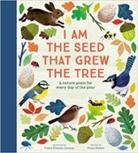  I am the Seed that Grew the Tree  Fiona Waters |  | 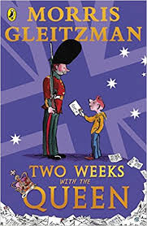  Two Weeks with the Queen  Morris Gleitzman

