Theme/Term | Destruction & preservation Autumn 1 |  | Space & our world Autumn 2  Cycle A
Writing Root/  Spelling Seed Text | 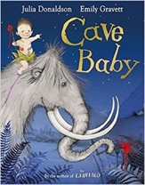  Cave Baby  Julia Donaldson and Emily Gravett | 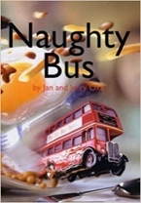  Naughty Bus  Jan Oke and Jerry Oke |   We Are Water Protectors Carole Lindstrom |   Astro Girl  Ken Wilson-Max
Length | 10+ sessions, 2+ weeks | 16 sessions, 3+ weeks | 15 sessions, 3 weeks | 11 sessions, 2+ weeks
Outcomes | Narrative retellings  Labels and captions, informal letters | Own adventure stories  Letters, diaries, sequels, non-chronological reports | Environmental campaign  List poems, non-chronological reports (animals), chron reports (life- cycles), character description, protest signs | Fact files about being astronauts  Writing in role, commands, ‘how to’ guides
Literary Leaf Text | Class reading sessions will follow Little Wandle recommendations for the Autumn term for all children
Length
Theme/Term | Similarities & differences Spring 1 |  | Change & relationships Spring 2
Writing Root /  Spelling Seed Text | 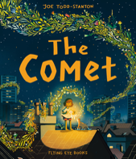  The Comet  Joe Todd-Stanton | 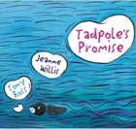  Tadpole’s Promise  Jeanne Willis |   The Owl and the Pussy-cat  Edward Lear | 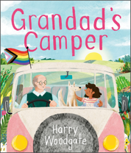  Grandad’s Camper  Harry Woodgate
Length | 15 sessions, 3 weeks | 15 sessions, 3 weeks | 10 sessions, 2 weeks | 15 sessions, 3 weeks
Outcomes | Own version narrative  Posters, letters of advice, poem, description, writing in role, recipes | Own version narratives  Simple explanations, speech and thought bubbles, setting descriptions, extended explanations | Rhyming poems  Letters, interviews, lists, instructions | Sequel narratives  Labels, memories poems, interviews, photo album captions, postcards
Literary Leaf Text | 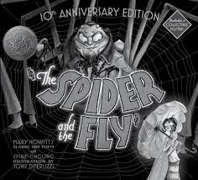  The Spider and the Fly  Mary Howitt and Tony DiTerlizzi |  | 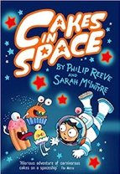  Cakes in Space  Philip Reeve
Length | 10 sessions, 2 weeks |  | 15 sessions, 3 weeks
Theme/Term | Fantasy journeys Summer 1 |  | Structures & materials Summer 2
Writing Root /  Spelling Seed Text | 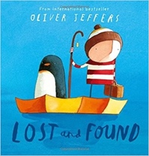  Lost and Found  Oliver Jeffers | 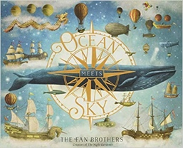  Ocean Meets Sky  Eric Fan and Terry Fan |   The Great Fire of London  Emma Adams | 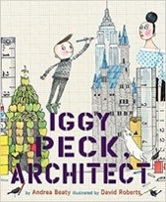  Iggy Peck, Architect  Andrea Beaty & David Roberts
Length | 15 sessions, 3 weeks | 15 sessions, 3 weeks | 15 sessions, 3 weeks | 15 sessions, 3 weeks
Outcomes | Own version ‘losing/finding’ narratives  Character descriptions, retellings, advice, instructions, non-chronological reports | Own version fantasy world narratives  Setting & character descriptions, labels, diaries, postcards, captain’s logs, instructions, dialogue | Information booklets  Persuasive poster, warning posters, speech bubbles, letters of advice, certificates | Fact files  Labels, character comparisons, character descriptions, building descriptions, posters
Literary Leaf Text | 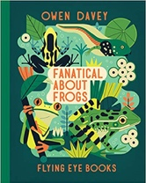  Fanatical about Frogs  Owen Davey |  | 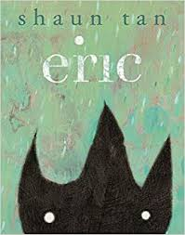  Eric  Shaun Tan
Length | 12 sessions, 2+ weeks |  | 12 sessions, 2+ weeks

Theme/Term | Heroes & villains Autumn 1 |  | Helpfulness & kindness Autumn 2  Cycle B
Writing Root /  Spelling Seed Text | 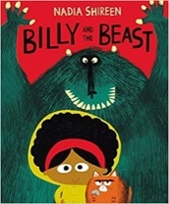  Billy and the Beast  Nadia Shireen | 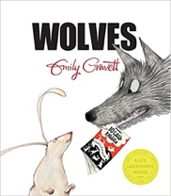  Wolves  Emily Gravett | 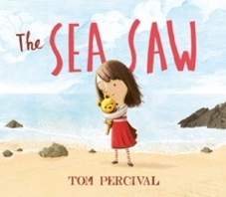  The Sea Saw  Tom Percival | 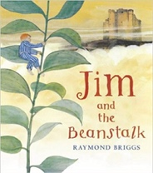  Jim and the Beanstalk  Raymond Briggs
Length | 15 sessions, 3 weeks | 15 sessions, 3 weeks | 15 sessions, 3 weeks | 15 sessions, 3 weeks
Outcomes | Own version ‘defeat a monster’ narratives  Wanted posters, summaries, emails, character descriptions, recipes | Non-chronological leaflets  Captions, information writing, character descriptions and comparisons | Own version narrative  Writing in role, notes of advice, missing posters; diary entries, letters of thanks | Sequel stories  Narrative retellings (including dialogue), thought bubbles, informal letters
Literary Leaf Text | Class reading sessions will follow Little Wandle recommendations for the Autumn term for all children
Length
Theme/Term | Storybook bears Spring 1 |  | Beasts & monsters Spring 2
Writing Root /  Spelling Seed Text | 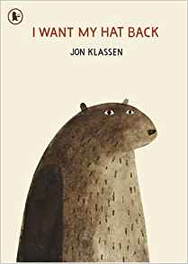  I Want My Hat Back  Jon Klassen | 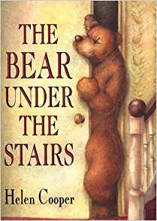  The Bear Under the Stairs  Helen Cooper | 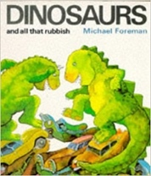  Dinosaurs and all that Rubbish  Michael Foreman | 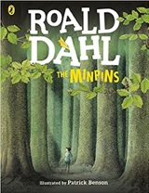  The Minpins  Roald Dahl
Length | 15 sessions, 3 weeks | 15 sessions, 3 weeks | 15 sessions, 3 weeks | 15 sessions, 3 weeks
Outcomes | Story sequels  Questions, speech bubbles, letters, lists | Information texts  Letters, retellings, own version narratives | Pamphlets  Letters, setting descriptions, instructions, narrative retellings, pamphlets, posters | Own version adventure narratives  Danger posters, setting descriptions, character descriptions, information reports, postcards
Literary Leaf Text | 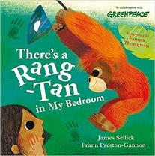  There’s a Rang-Tan in my Bedroom  James Sellick |  | 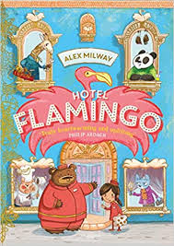  Hotel Flamingo  Alex Milway
Length | 10 sessions, 2 weeks |  | 15 sessions, 3 weeks
Theme/Term | Fictional Worlds Summer 1 |  | Urban and rural adventures Summer 2
Writing Root /  Spelling Seed Text | 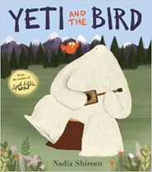  Yeti and the Bird  Nadia Shireen |   Pig the Pug  Aaron Blabey | 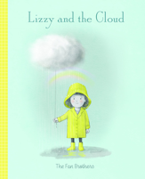  Lizzy and the Cloud  The Fan Brothers |   Last Stop on Market Street  Matt de la Peña
Length | 15 sessions, 3 weeks | 15+ sessions, 3+ weeks | 15 sessions, 3 weeks | 15 sessions, 3 weeks
Outcomes | Own version narratives about unlikely friendships  List of rules, letters, postcards, character escriptions | ‘How to’ guides  Character comparisons, fact sheets, shared poetry, own version narratives | Guidebooks  Descriptions, adverts / market stall pitches, letters of advice, postcards in role | Own version narrative  Metaphor poetry, simple character descriptions, interview questions, senses poetry, adverts, advice slips, letters
Literary Leaf Text | 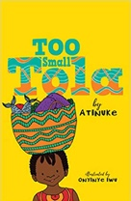  Too Small Tola  Atinuke |  | 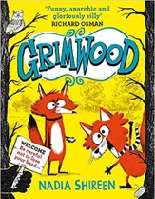  Grimwood  Nadia Shireen
Length | 12 sessions, 2+ weeks |  | 15 sessions, 3 weeks

